# Purdue CGT 370 Assignment 3 Maps (1)

DUE: Feb 12 2019 (EST 11:29 am)

As we have learned from the lecture, maps interpret many relationships between data and spatial-data. In this assignment, you are taking an analyst job and exploring INDIANA education and workforce data (https://hub.mph.in.gov/group/education-and-workforce).

## Given a huge dataset, you need first scan all datasets and figure out which one is most attractive to you. For instance, you may be interested in the “poverty status in last 12 months”. (<https://hub.mph.in.gov/dataset/poverty-status-in-last-12-months/resource/b1f807f5-9a13-4bc9-b01d-50efe020fc57>)

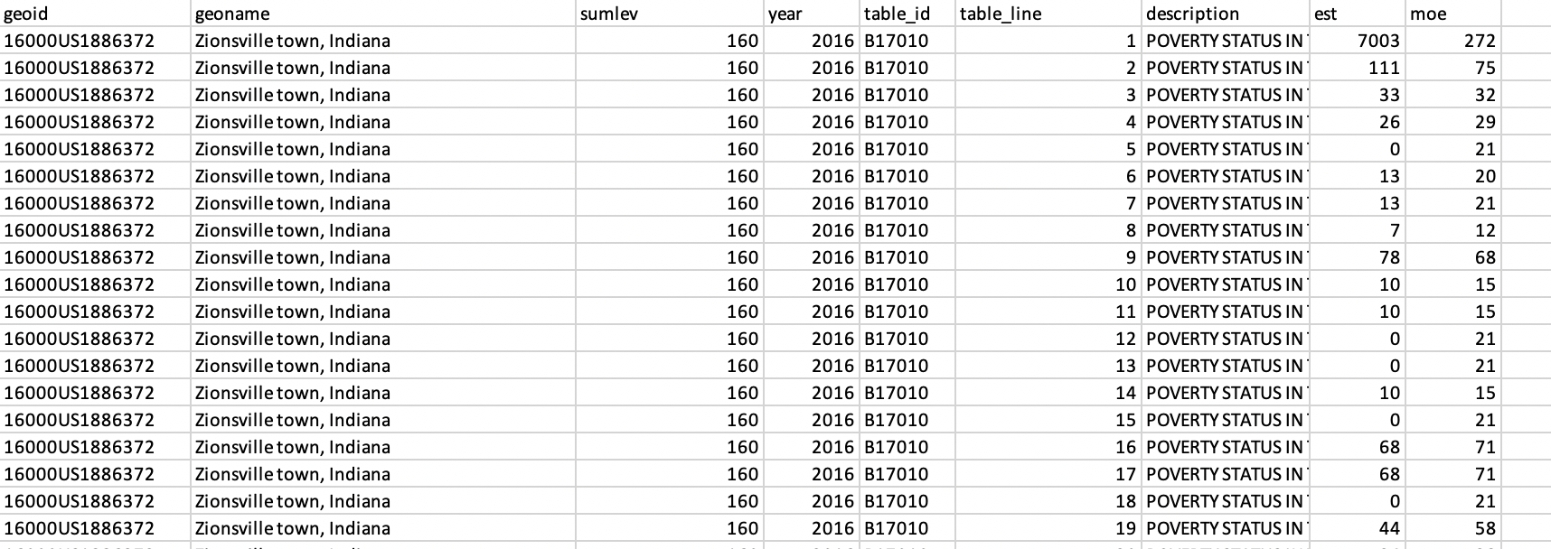

Let’s first understand what the title-blocks are. Notice, since normally the dataset is quite large and contains many information, we’d better apply data abstractions.

In this assignment, we need to map the dataset you select to a geo-map (Indiana State). Use colors scaler to represent the data size. Write down a few conclusions (less than four paragraphs) about what you learn from this dataset. (Try to avoid from answering only some basic information like who is the poorest or richest county)

Requirements:

* A choropleth map on a specific dataset.
* Title of the map
* Names of all counties
* Basic interaction (eg. Mouseover, click) to reflect information
* Legend of mapping color to number

Example:

